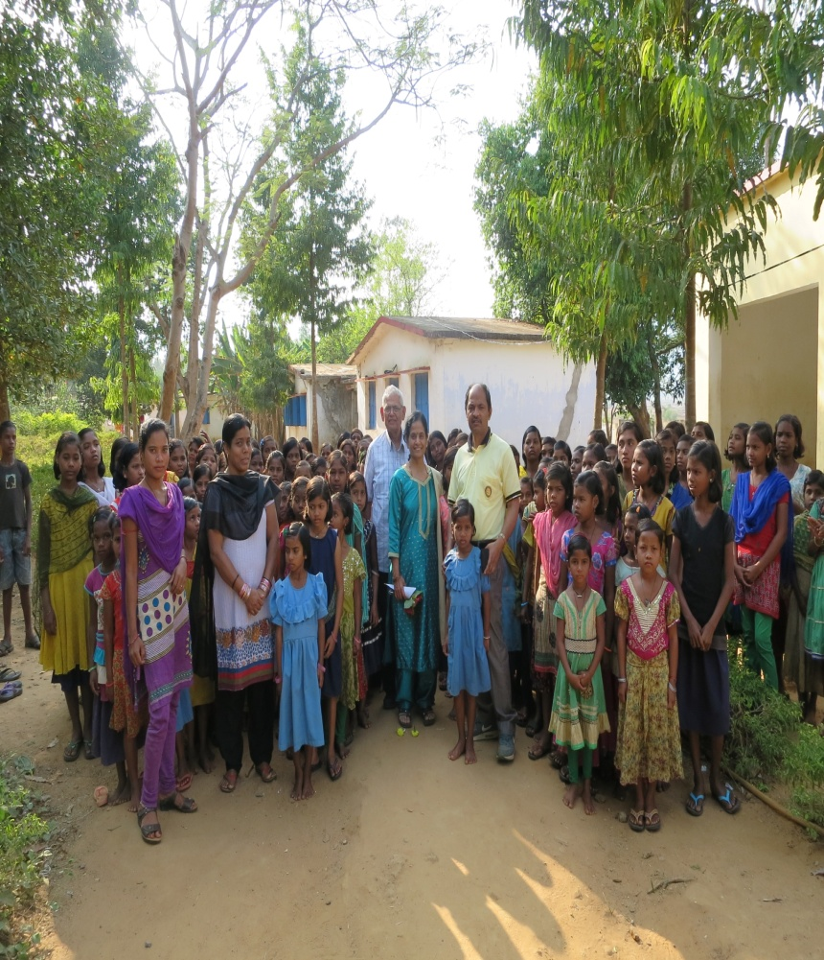
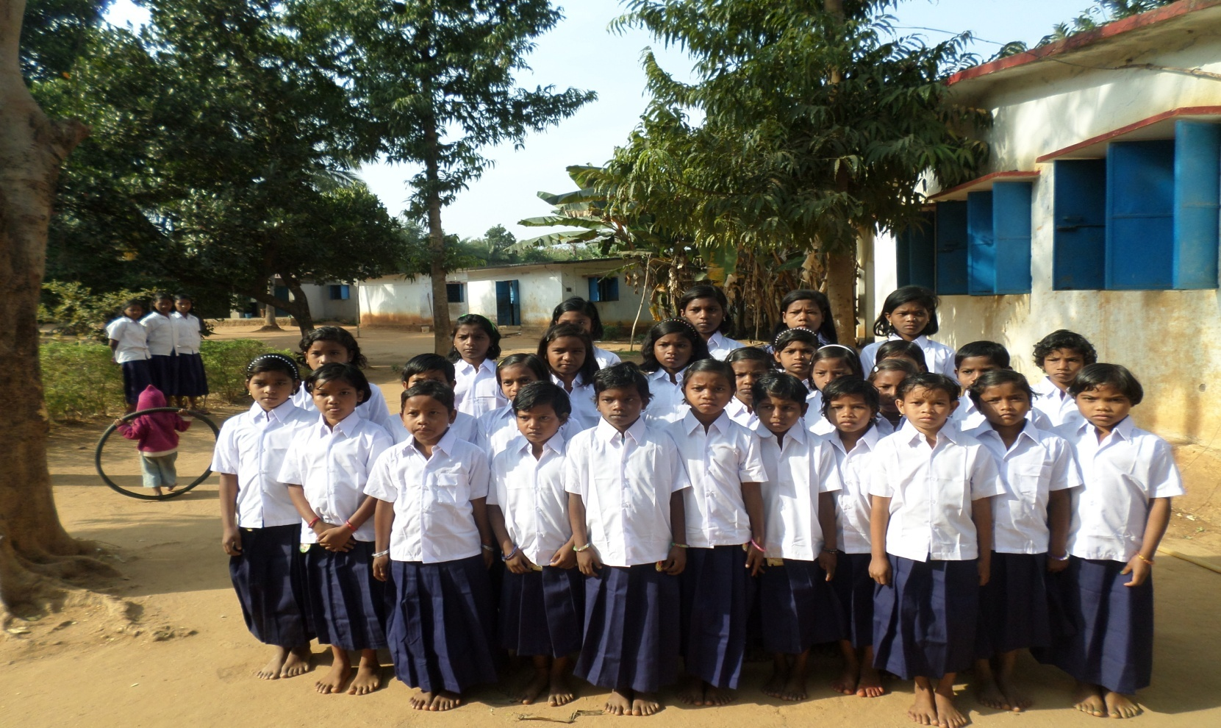
Need your sponsorship support for tribal girl’s education
Rayagada is one of the backward districts under KBK of Odisha India. The population of the district is 967911. Average literacy rate of Rayagada district is 49.76 percent (2011) . Male literacy rate in Rayagada district of Odisha is 61.04 percent. Female literacy rate in Rayagada district of Odisah is 39.19 percent. Total literates in Rayagada district are 407,735 people. Out of this, more than 35% of the total literate population only knew how to sign their name instead of proving a thumbprint. Due to poverty, low per-capita income and inaccessible areas people are suffering a lot. The district is touching the border of Andhra Pradesh, so people seasonally migrate for jobs. Noxal moment is going on in the district which is severely affected and breaks the development work in the area. Migration is another cause for increased dropout rate of children from schools. During the period of migration nobody takes care of the children’s educations. Children and women are suffering more in the community areas. Due to low literacy and high dropout rates, community attitude towards girls’ education is very negative. Keeping in view the problem, NYSASDRI initiated an educational complex for tribal girls at Hukumtola Village under Bisama Cuttack Block of Rayagada district. Since 1997 NYSASDRI has been active in female education in the village of Hukumtola and started the school with 50 tribal girls. The programme is supported by the Ministry of Tribal Affairs and provided a grant for running the school (recurring support).Also supported initial building cost to accommodate the 50 girls. Currently 172 tribal girls aged 6-14 years are staying in school campus and receiving primary education (class I to class V) between 10 to 100 miles area as it is fully Residential School. Due to the lack of sleeping beds, kitchen utensils, furniture, a bore well, and dining, the girls are facing many difficulties. Female students are defecating in open spaces and suffering from dysentery, round worm, diarrhea, fever, and/or malaria ( due to shotage of water). Due to the unavailability of cots, students are sleeping on the floor.
Type of Target group to be benefited –
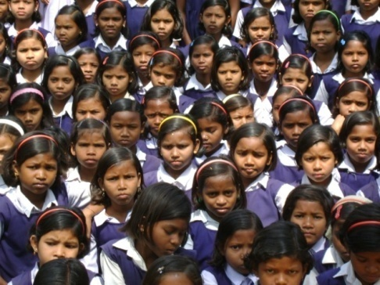
Tribal girls ranging from ages 6-14 years of age who are out of school will be benefited through this programme.
What is the major focus of the project?
- Enrollment of tribal girl children
- inclusion with mainstream society
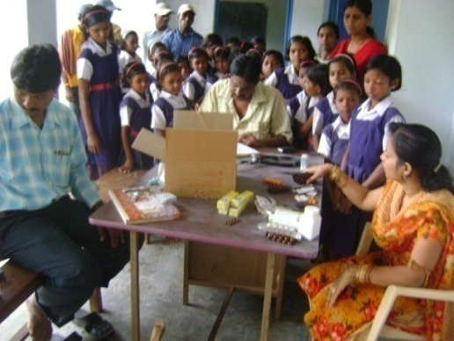
- Provide quality of education and improve their higher study
- Increased girl’s literacy in the area.
Now 172 tribal girls from standard I to V are continuing education along with hostel facilities which is inadequate for them.
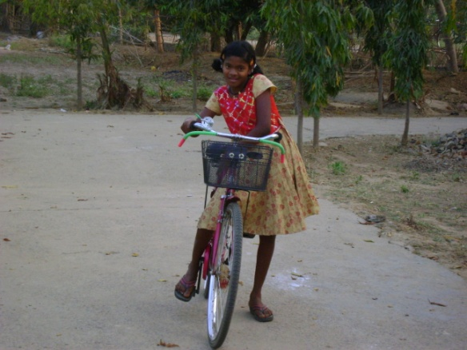
The education complexes based at the Hukumtola Village in Bisam Cuttack block of Rayagada District, Odisha. During their stay period they are provided with food, clothes, accommodation, health checkups, teaching and learning materials along with monthly examinations. During leisure time, both the teacher and the student do socially productive work like planting trees, cleaning the surrounding area, cultivate vegetables and flowers etc. Each year 20 to 30 tribal girls pass out from the school and continue on to higher studies in different areas. The teaching method is based on a formal syllabus as per the guidelines of the Govt. of Odisha. In addition to this, we have imparted teaching learning and other activities based on curricular and, co-curricular A parents-teachers association and a mother committee functioning in the school.
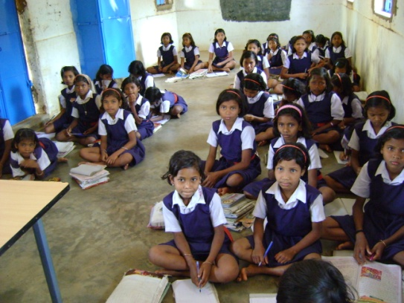
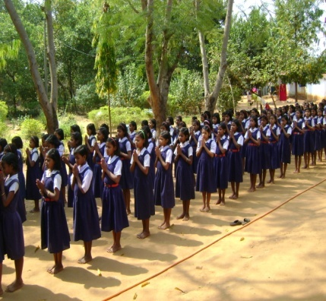
Essential items like food, clothes, soap, oil, different teaching and learning materials, regular fortnightly health checkups with medicines, vocational training etc are being supplied to the school children on a regular basis. In this context based on the high demand of education in the school more parents are attracted to send their children to the school but due to inadequate Space, Beds, we are unable to manage the existing 172 students for accommodation, dining and classroom with the existing infrastructure. Now we are facing financial problem for managing the school. There is not any regular source of income to maintain the school. Many girls have dropout of the school because their family don’t send them anymore For the interest of the mentioned noble cause we are showing our interest to you for grant in aid fully or partially to fulfill the mission of construction of Kitchen and dining, purchase of beds, supply of additional food stuff, uniform dress and teaching learning materials for students.
Sl. No | Particulars | Amount In INR
A | Students
1. | Food stuff for per students per month for 10 month | 7500
2. | Uniform dress /shoes 2 pairs per Annum | 1000
3. | Books and teaching learning materials per annum | 1000
4. | Health care for 10 month | 500
5. | Co curricular activities for 10 month | 1000
 | Per students for academic year | 11000
B | Campus
1 | Construction of Kitchen -!0’ x 15’ = 150sqrfit | 180000
2 | Construction of dining | 300000
3 | Purchase sleeping beds (100no) @5000 | 500000
4 | Installation of bore well/ water pump etc –(!no) | 200000
5 | Computer with printer 1set , | 50000
6 | Tailoring machine 05 no x INR 10000 | 50000
7. | Solar light | 200000
C | Staff
1 | One head master INR 7000 Per month x 12 month | 84000
2 | Three teacher INR 5000 Per month x 12 month | 180000
3 | One language teacher INR 5000 Per month x 12 month | 60000
4 | Two cook, one peon, one night watcher =4staff INR 4000 per month x 12 month | 192000
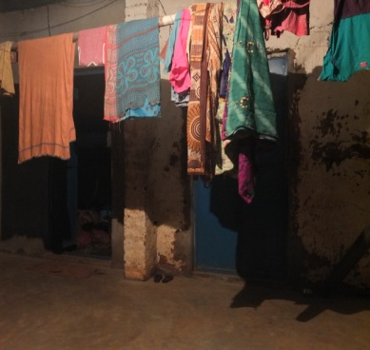
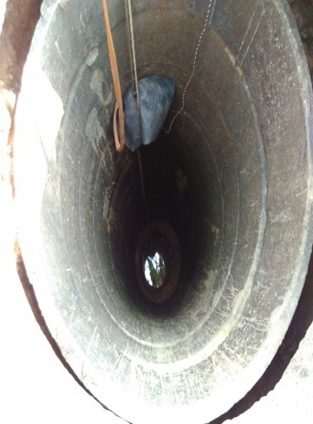
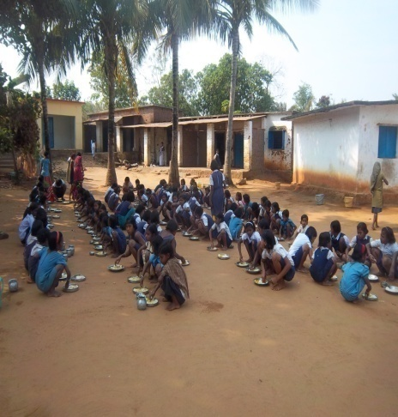
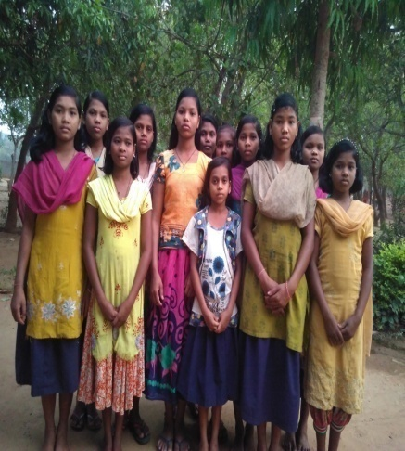
Present need of NYSASDRI Educational complex, Hukumtola , Rayagada

