Request for sponsorship programme

Support to tribal children for proof their talent
The Odisha Multipurpose Demonstrative (ODM) Community School was established in February, 2010. Its objective is to enhance and enrich the quality of modern education in rural tribal areas. It is managed by NYSASDRI, which is a state level NGO with more than two decades of experience in the field of education. The school is running with up-to-date facilities, in order to establish a strong base of successful students and also to increase awareness in the local population. We plan to follow this by an extension of the school to students from grades KG to V, in order to provide them a proper secondary education.
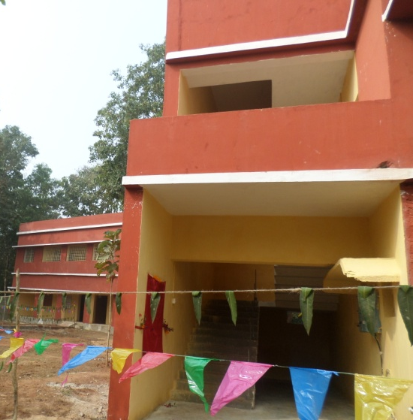
The school’s curriculum will match with the Indian CBSE standards, while its structure will be based on the English Medium School type. All subject matters will be taught in English, and it is believed that this will greatly improve the ability of the children to follow up with higher education. Today, 65 children enrolled in the School from class Kinder Garden to Standard V (Kinder Garden, Standard I, II III , IV, V) are receiving education. Out of 65, many students are dropped out due to financial crisis. In the year 2016 1st April onwards the School renamed to NYSASDRI School for greater interest of the poorest and vulnerable community .

Location: The NYSASDRI School is located at Kokuajhara, Kashipur, Gondia Block, Dhenkanal district, Odisha PIN- 759016,
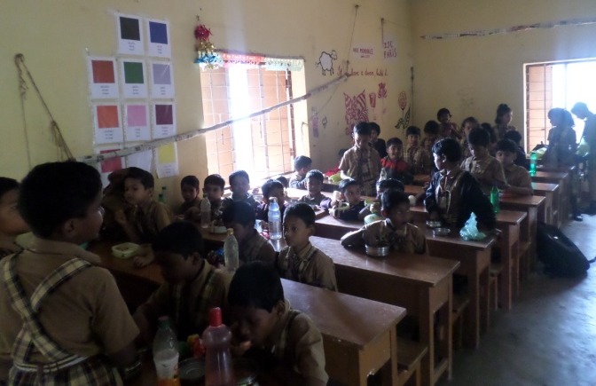
Objective: Thanks to successful adequate facilities and societal behavioural changes, the objective of the school is to help the poorest children from the villages and tribes of the Dhenkanal district in Odisha to be in the position to one day compete with the national elite.
Specifically, the objectives are:
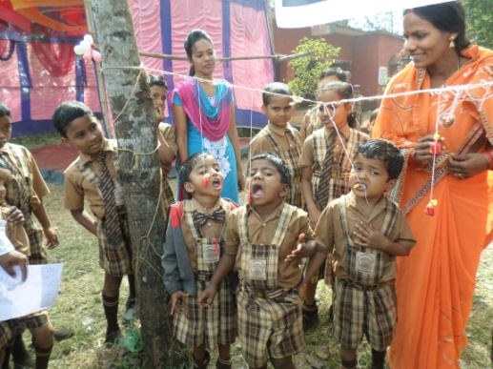
- Setup a campus in which local children from the poorest families have access to world-class education from KG to grade V;
- To secure facilities in order to provide these children with adequate educational, safety and studying environment;
- To expand the school to reach more children and offer KG to V education;
- To raise awareness and concerns about the importance of education in the local population
Present facilities
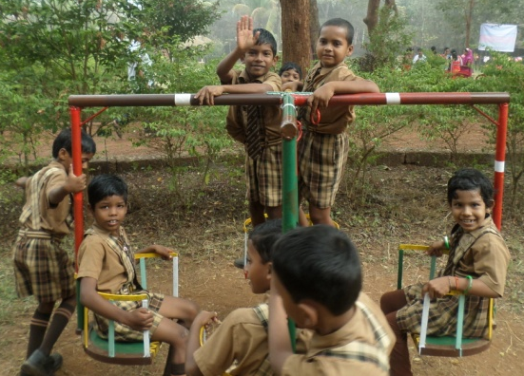
- 5 classrooms and an office room
- One indoor play & rest room
- guest rooms with attached bathrooms
- Residential staff and care-taker's house
- Group toilet
- Hostel facilities for 25 girls and 25 boys
SPORTS AND PLAYGROUND:
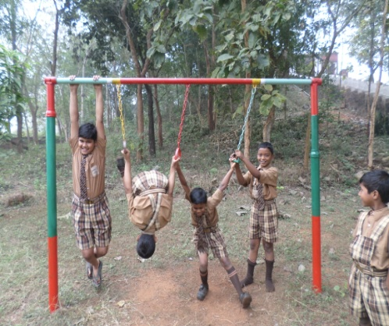
Indoor and outdoor games available
Playground with Swings, See-saw, Slide, Merry-go-round and Sand-pit
Plenty of rooms for all type of games (basketball, foot ball, skipping...) (Kho-Kho, Kabadi
TRANSPORT:
Hire transport facilities for its students.
Co curricular activities:
Art and Craft (Drawing, Painting, Modeling...), Physical Training,Singing,Dance and Music
Drama,General knowledge,Appropriate Social Behaviour,Games,Yoga and Meditation
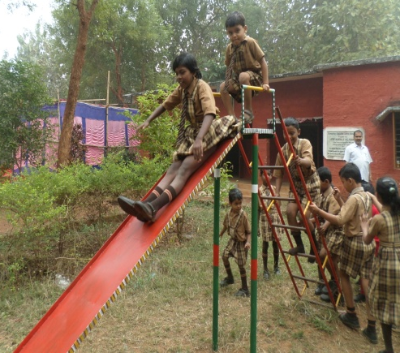
Computer facilities: Set up computers in the School campus for the teacher to demonstrate their utilization to the children for their professional development. Children from standard 1 are practicing and learn the basic information about computers.
Present need
NYSASDRI has developed high quality educational centres in an area where school are often missing. On this grounds NYSASDRI the School in the Dhenkanal district. Thinking one step ahead, the organization seeks to fill the education gap that exists between rural and urban areas. It is an innovative high quality school, based on English teaching. In a country where only 10% of the people speak this language, the NYSASDRI School gives the children life changing opportunities in the area.
The parents’ financial problems reduced the school incomes; burden became more on NYSASDRI for day to day management of the recurring expenditure. So out of total enrolment many students are dropout due to their parents are unable to pay or discontinue their payment. The enrolment of more children would lead to a diminution of the financial burden for NYSASDRI. In this connection NYSASDRI constructed a 50 bedded hostel for its students for the purpose of residential facilities for students and avoid transpiration charges, but parents are also not able to pay Rs. 1500 hostel boarding charges for children per month. So we met children’s parents that had dropped out and found out that even if they would like their children to continue studying in the School but they can’t afford to give Rs1500- per month (hostel charges with school charges). As they were ashamed not being able to pay, they stopped sending them. They need some support for few years to be able to give their child a good education without worried about the cost.
Dream of poor people and a bright future of a child can be possible through your support!
Giving those Rs.1500/- per month will allow one child to come to school every day and follow good classes. You may direct support to children or link with any kind hearted person for this noble causes
External support is needed for few years until an increscent of children’s strength would made the school self dependant.
A Child needs the following (per child per month)
Particulars | For hostel (One Unit)
Fooding and accommodation in hostel | 900
Tuition fee | 300
Books and uniform (1000+1200= Rs 2400 per Annum) | 200
Health care per month | 50
Co curricular activities per month | 50
Total requirement for month per Child in INR | 1500

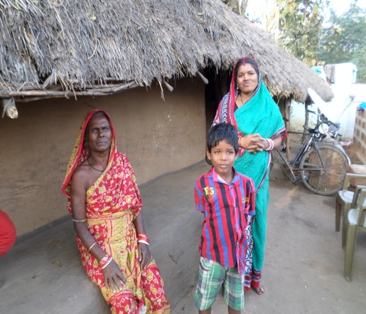
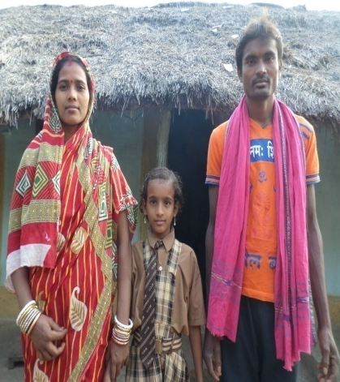
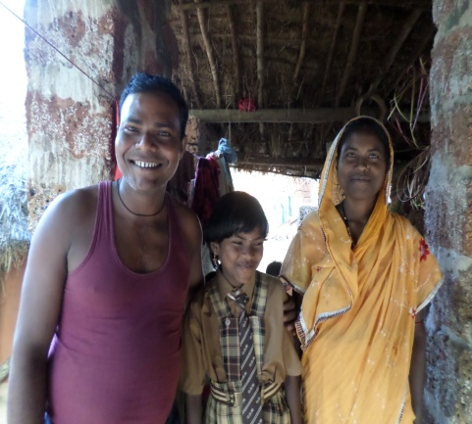
Our students from poor and tribal community – NYSASDRI School , Kashipur, Dhenkanal

 | 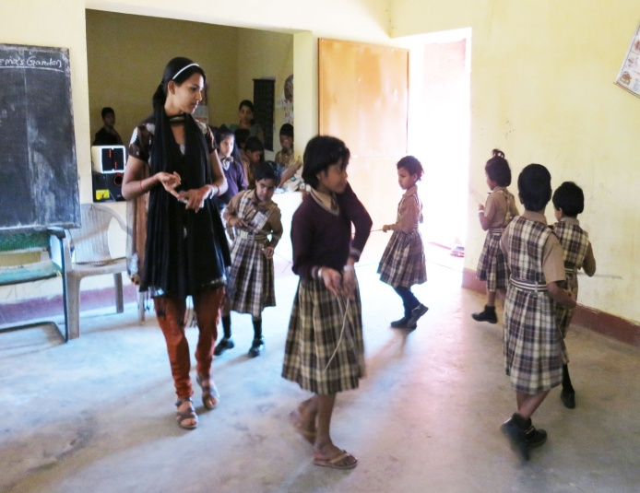
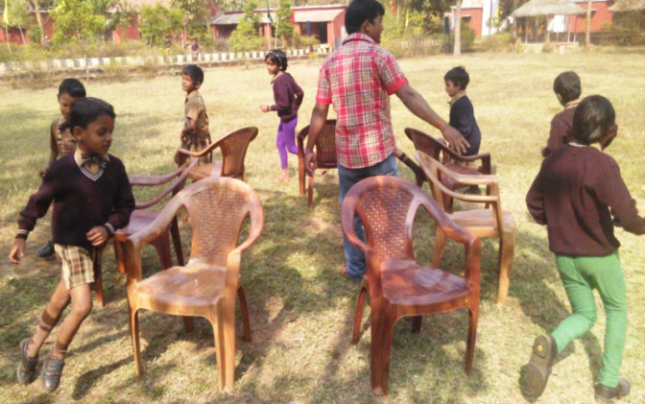 | 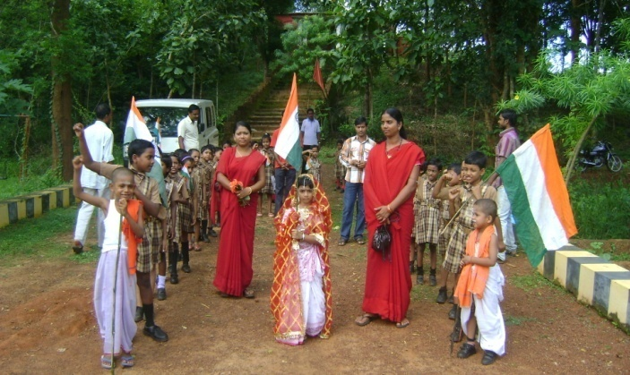
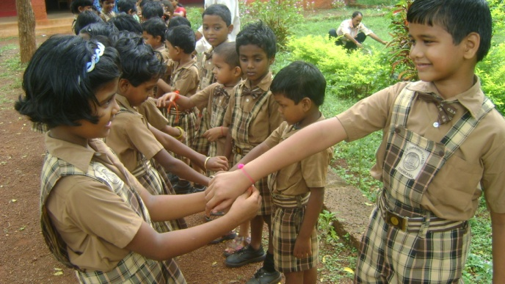 | 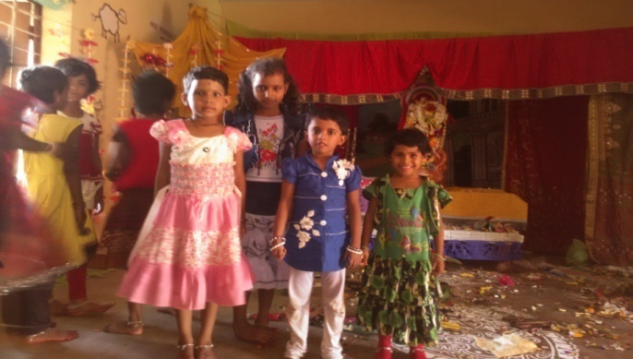
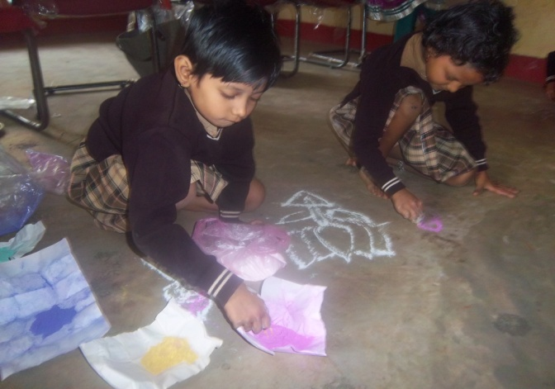 | 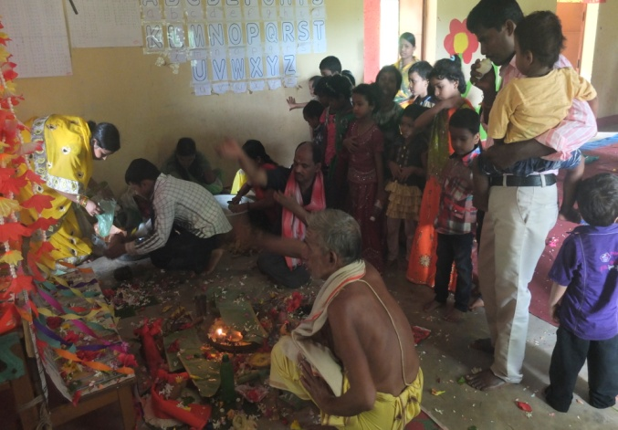
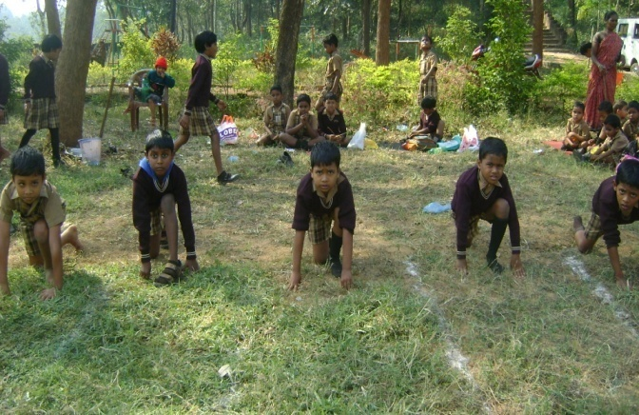 | 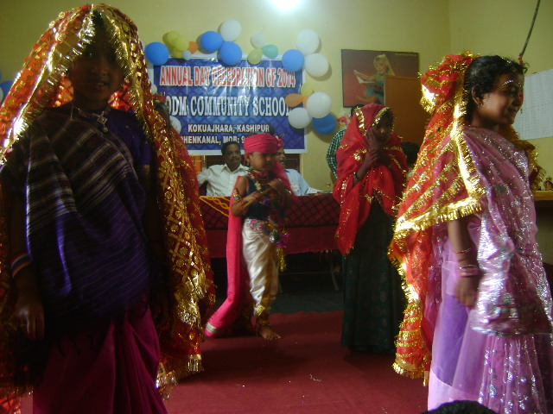
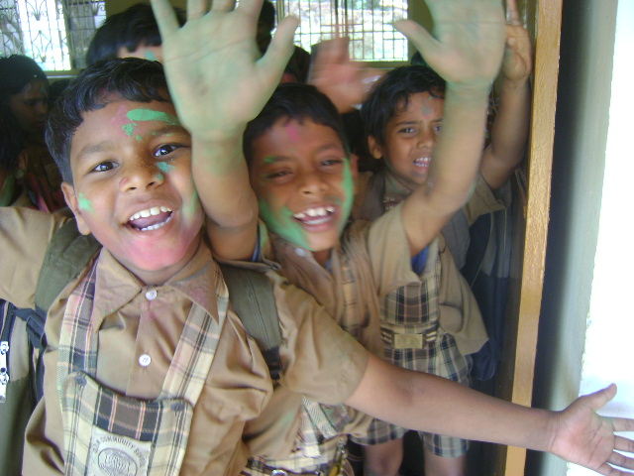 | 